Jenkins CI/CD Pipeline - Ansible, Docker, Github Webhooks on AWS

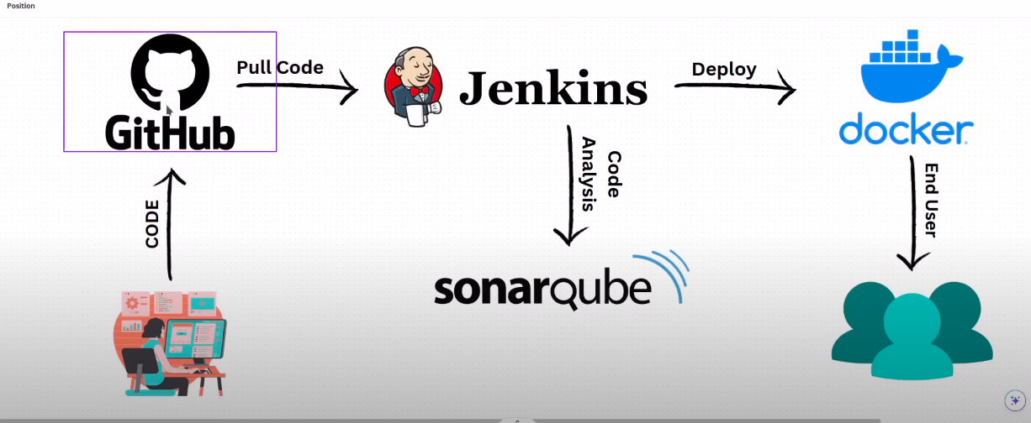

GitHub Webhooks ----- When ever an event / code change happened in GitHub, It will trigger an Event in Jenkins

Requirements
-----------------

1. Download a css Template from browser https://www.free-css.com/free-css-templates
and extract it.

2. Login to the GitHub, Create a Repositories called <Jenkins-Docker-Sonarqube>

3. Push the css template code to this Repository <Jenkins-Docker-Sonarqube>

Go to AWS Console
------------------------

- Create 3 Instances 1. Jenkins 2. Sonar-Qube (t3.small) 3. Docker

Login to Jenkins Instance ----> sudo apt update -y --> chnage the hostname <Jenkins> ---- Now install Jenkins --> go to jenkins.io website and install it ---- first install jave ---> sudo apt search openjdk ---->

- Jenkins runs on port 8080, so add rule in jenkins server security group

copy the public ip of jenkins ----> and paste it in brreowser -----> do the steps needed

Login to Jenkins Dashboard
------------------------------------

- Create a New job called <fech the code> ----- freestyle ---- click ok
- go to Source code management tab --- select git ---- and give url of the pepository
- go to build triggers ---> select github triggers for GITscm polling
- Next go to the GitHub <Jenkins-Docker-Sonarqube> Repository ----> click settings --- click on the webhooks --- add webhook – copy th jenkins url http://<ipaddress:8080> ---- and paste at payload url ------ after paste the url write “ /github-webhook/ “ http://<ipaddress:8080>/github-weebhook/ --- select let me select individual events , mark pull requests and pushes --- add webhook

Verify the webhook is working or Not
----------------------------------------------
Build the pipeline ------ it get sucess it clone data from github --- and astor it on var/lib/jenkins/workspace

- Now add a new file in github ----- and commit it

- Now you can see, the jenkins automatically fetch the changes and run the pipeline.

===================================================================

Login to Sonar-Qube
--------------------------

sudo apt update -y ----> change hostname <Sonar-Qube> ------> install sonar-qube ----

For sonarqube we need Java17 ---- install java17 first ---- sudo apt install openjdk-17-jre ----
go to browser --- sonarqube download --- https://www.sonarsource.com/products/sonarqube/downloads/

Her we download the community edition --- for that right clink on the DOWNLOAD FOR FREE and copy the link....

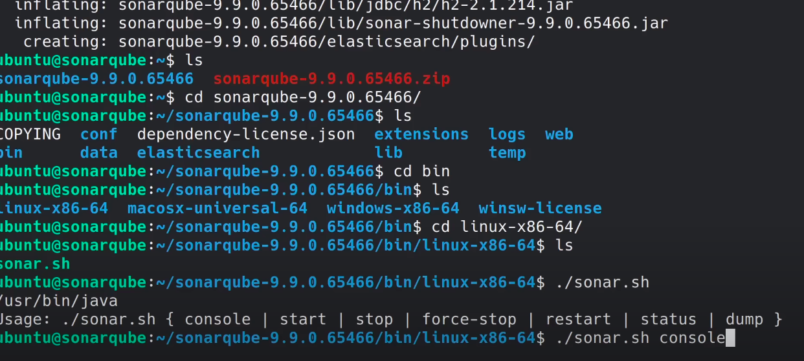
- go to terminal --- paste the linlk with wget command ------- wget paste the linlk ---- download completed ---- see here it was zip file --- to unzip ---- first we install unzip ----- sudo apt install unzip -y ------ $ unzip <filename.zip> ---- ls

- Allow port to Security group ----- sonar-qube runs on port 9000 ------

- copy the publicip of sonar-qube ----- publicip:9000 ----- default user= admin and pwd= admin of soanr-qube

- Now we are loged into the Sonar-qube ------ click on manually --- name Onix-website

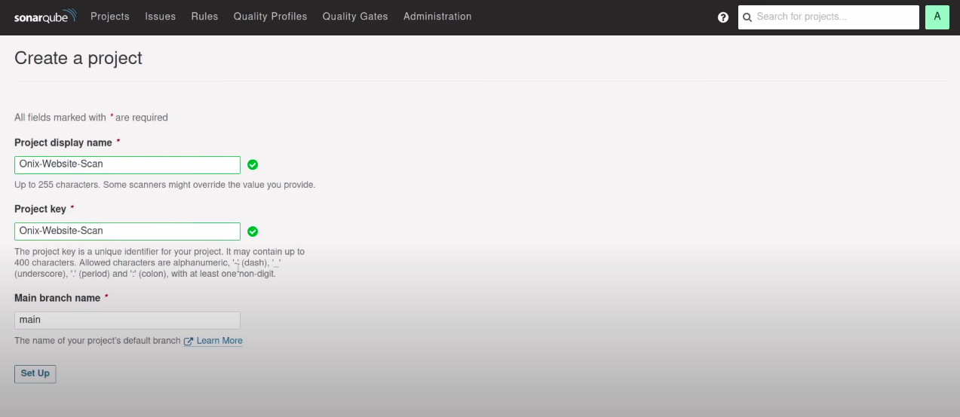

click on signup ----- after select CI --- we select jenkins ----- select github ---- click on configure analysis ---
click on continue ----- click on continue ----click on oter js,ts ----

so here we are copy the project key and paste it on any text editor -------- finish the tutorial ----- go to the admin user on the top right corner --- click go ot my accounts --- security ---- create a token --- name it Sonar-qube-token ---- select type global analysis token ---- click on generate token --- copy the token – paste it in text editor ----

Now go back to the jenkins ---> intall plugins ----> go to manage jenkins ---> manage plugins ---> Avaiable plugins ----> search for “ sonarqubescanner” ---> and Search for SSH2

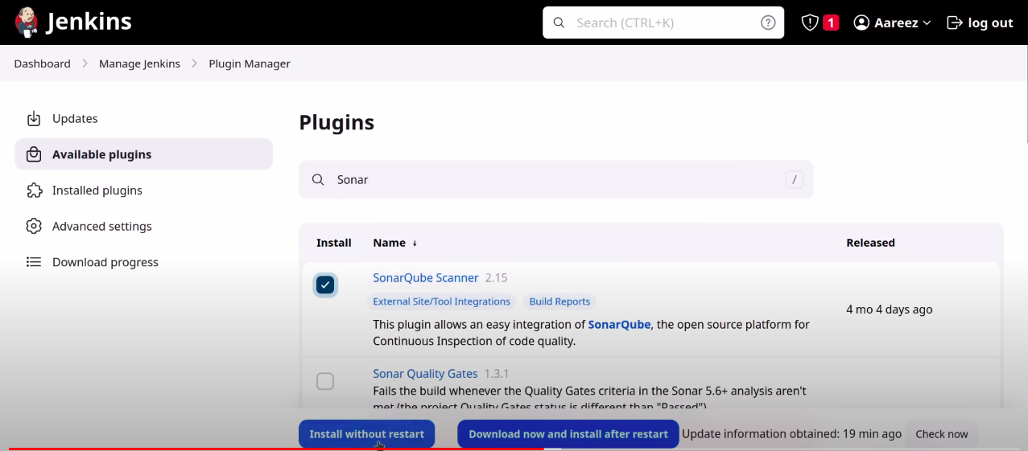
-- install 2 plugins 1. sonar-qubescanner 2. SSH2 Easy ----> install without restart --->

Next Step -----> go to manage jenkins ---> Global tool confiugaration ----> scroll down ---> you can see sonarqubescanner ----> click add sonarqubescanner ---> name SonarScanner ---> mark Install automatically
----> click save

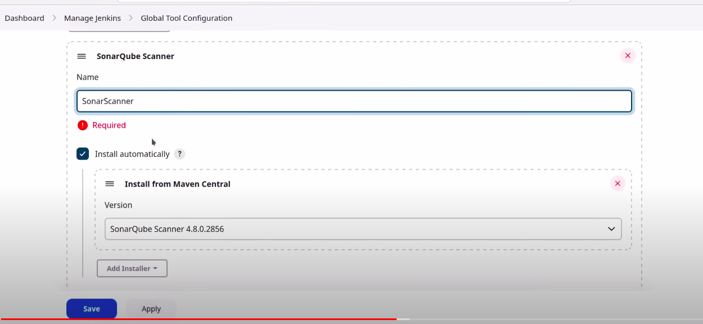
Next ---> go to manage jenkins ---> configure system ---> scroll down you see Sonar qube servers ---> click on add sonarqube ---> name Sonar-Server ---> url http://<publicip>:9000 --->
click Add ---> jenkins ---> Kind Secret text ---> paste token which we copy at Secret ----> ID Sonar-token --> Description Sonar-token ---> click add

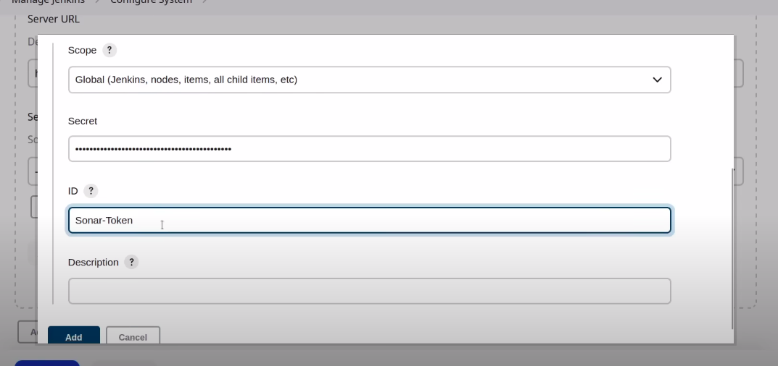

select token here --- click save

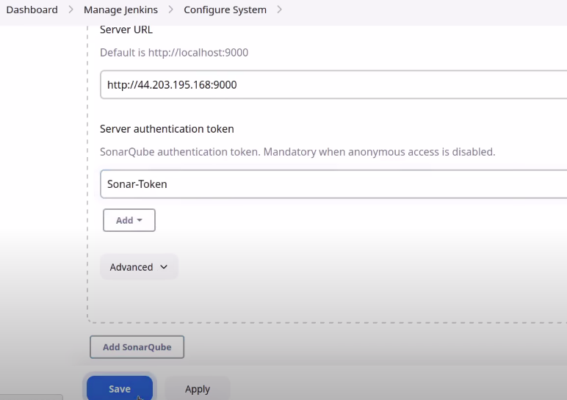

Next ---> go to the jenkins pipeline ---> go to the job we created ---> configure ---> Build step ---> seletc Execute Sonar Qube Scanner --->

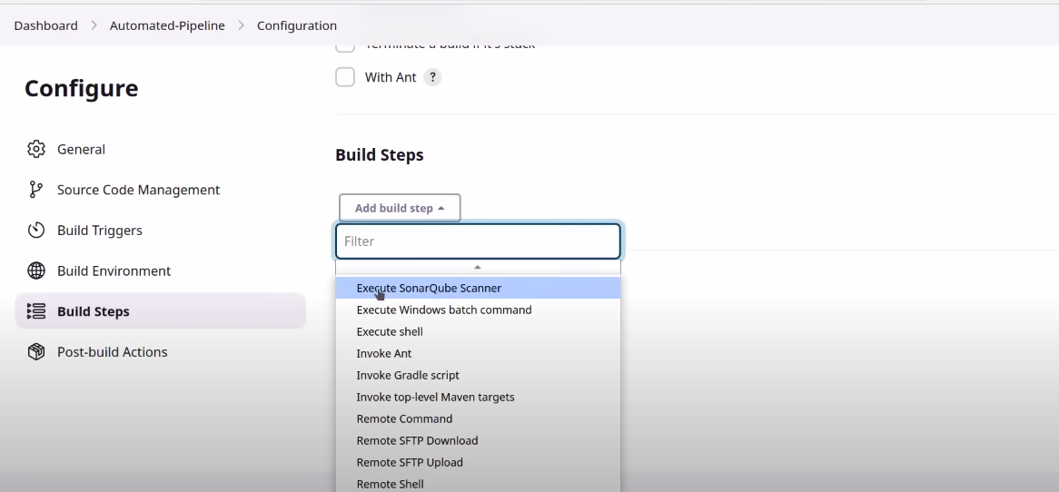
paste the key at Analaysis Properties --> and save it ------ Not token

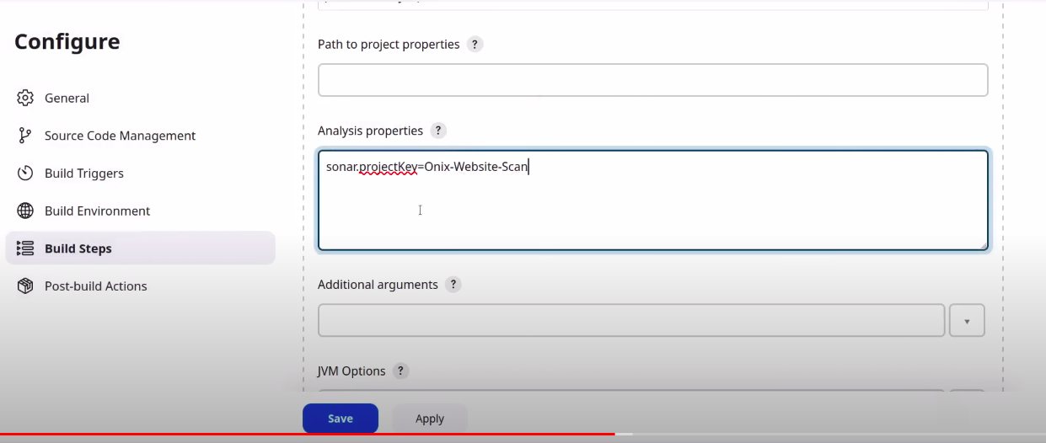

Next ---> go to jenkins --- go to job you created ---> build now..

Now the sonar qube is scanner our code .... lets go to sonar qube server dashboard ---> refesh the page

=============================================================================

Login to Docker Server
-----------------------------

change the hostname ----> docker ---- sudo apt update -y ----->

Install docker on ubuntu
------------------------------
https://docs.docker.com/engine/install/debian/

After installing docker ----> check the status of docker ----> when we install docker automatically a GROUP CREATED Named <docker> ---> add ubuntu user to docker group ---> sudo usermod -aG docker ubuntu

Next ----> we have to check the authentication from jenkin server to docker server OR vice-versa

Note: when we install Jenkins ----> Jenkins automatically creates a user called ‘ jenkins ’

go to docker server ---> switch to root user ---> sudo -i ---> vi /etc/ssh/ssh_config

un-comment PublickeyAuthentication
And change the PasswordAuthentication to yes

: wq

create password ----> passwd ubuntu ---- create password

Restart the sshd service
----------------------------
sudo systemctl restart shhd

Next ---> go to jenkins server ---> change to jenkins user ---> su jenkins --->

From here we connect to Docker sever
----------------------------------------------
ssh ubuntu@<publicip> ----> it asks password ---- now we login to ubuntu@docker machine --- exit from it ctl+d...

In jenkins server ---> change to jenkins user ---> su jenkins ---- create a key-pair ----> ssh-keygen --->

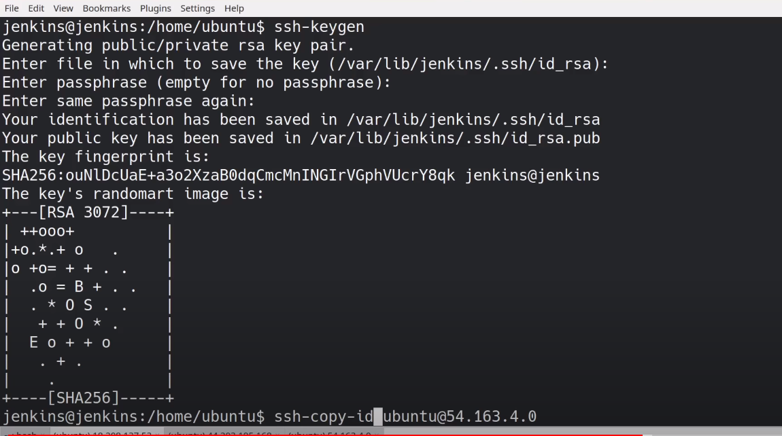
copy key to the ubuntu@docker server
------------------------------------------------
ssh-copy-id ubuntu@<publicip> ---------------------- Copy key from jenkins to docker server

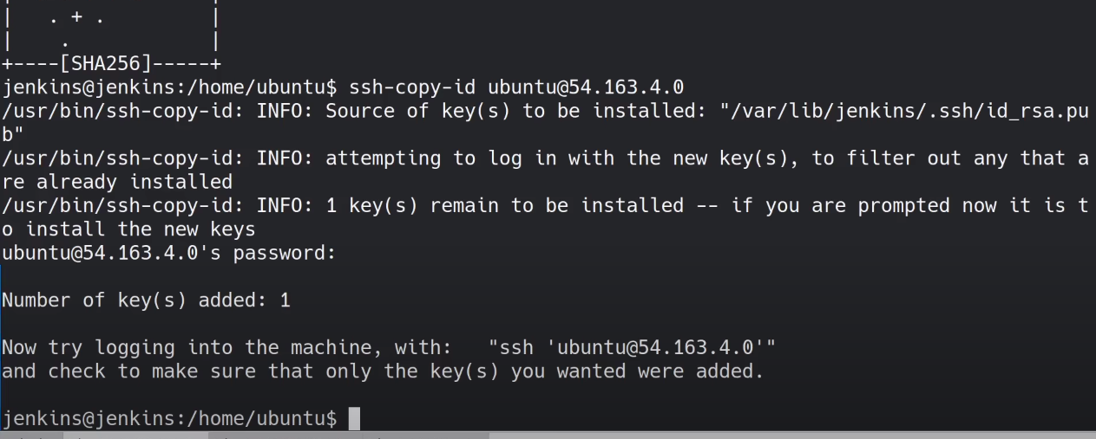

Verify the keys are added or Not
---------------------------------------
- Why we are adding keys to docker ----> what is the use ...?
- When we connect to docker server from jenkins server ----> it was asked password for that ---> to overcome this we added keys to docker ---- for checking

from jenkins server ---- ssh ubuntu@<publicip> ---- now it doesn’t ask password

Note: if you want to see the keys in docker ----> go to docker ---> cd .ssh ---> cat Authentication_keys --- here you see..

Next ---> go to jenkins dashboard ---> manage jenkins ---> configure system --> scroll down look for “Server Groups Center” ------> click Add under server group list ---> Group Name Docker-servers ---> user ubuntu ---> password <give the pass which you created> --- click save

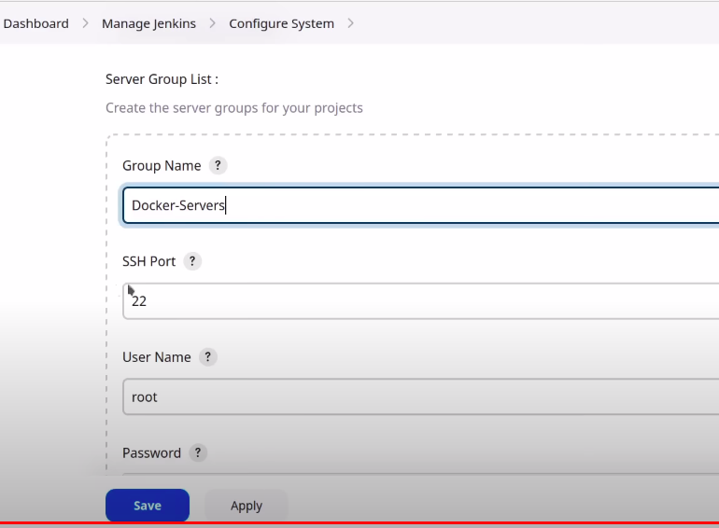

-- manage jenkins ---> configure system ---> scroll down ---> now we are going to add server list --> click add --> server Groups Docker-servers ---> Server Name Docker-01 ---> Server IP <public ip of docker server>
---> click save

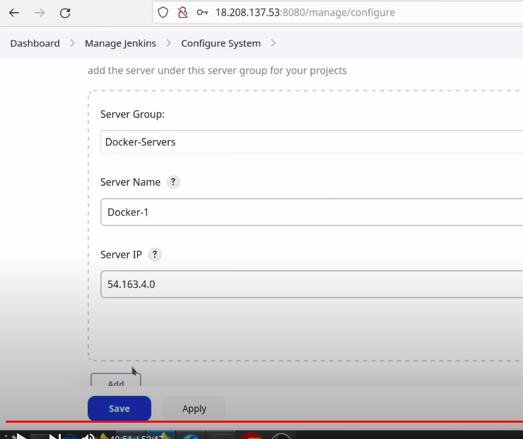

Next ---> go to pipeline job ---> configure ---> scroll down ---> add build step section ---> drop down --> select remote shell ---> select target server -----> create a file ---> touch test.txt --> save

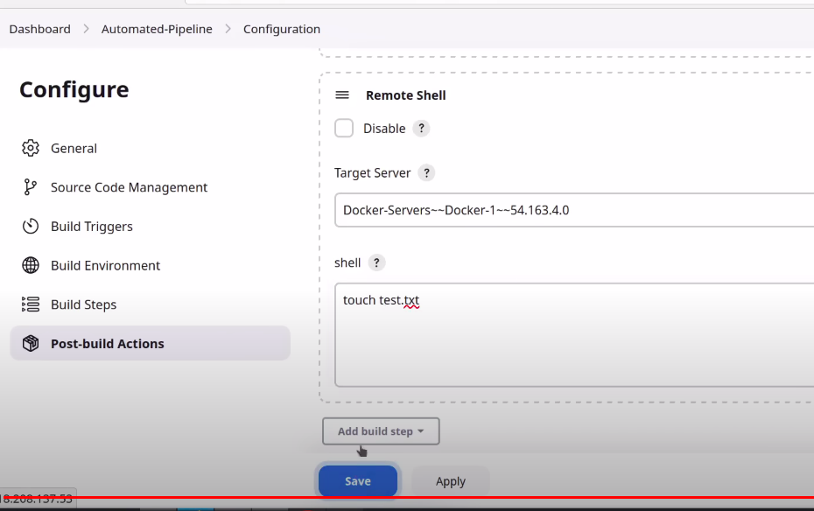

Now Build the pipeline ---- to check it whwther it was working or not ---- Now he code is being scaned with sonar qube ----> when scanned it will run the command on the Remote server ---> its get sucess

Now lets go Verify ---> go to docker server ---> ls --- now we see test.txt

Now we are going to write a Dockerfile ---> installing a nginx server
--> go to docker hub ---> serach for nginx ---> Here we can see waht is the “default path for nginx” ---> niginx ---> default path is /usr/share/nginx/html

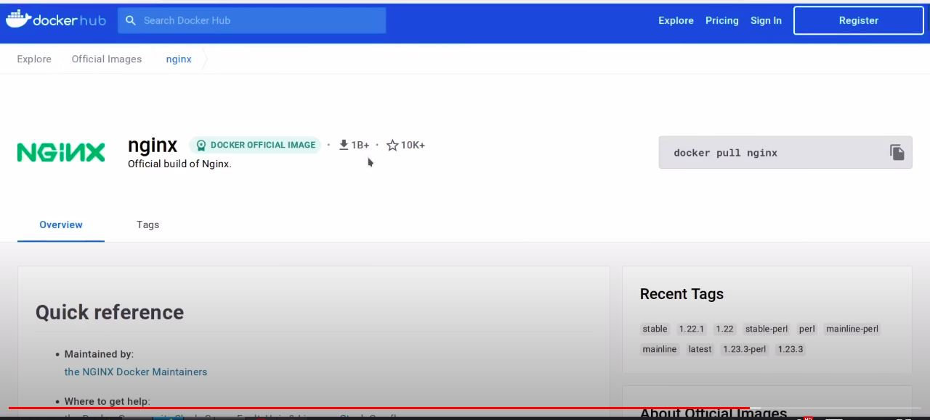

niginx ---> default path is /usr/share/nginx/html

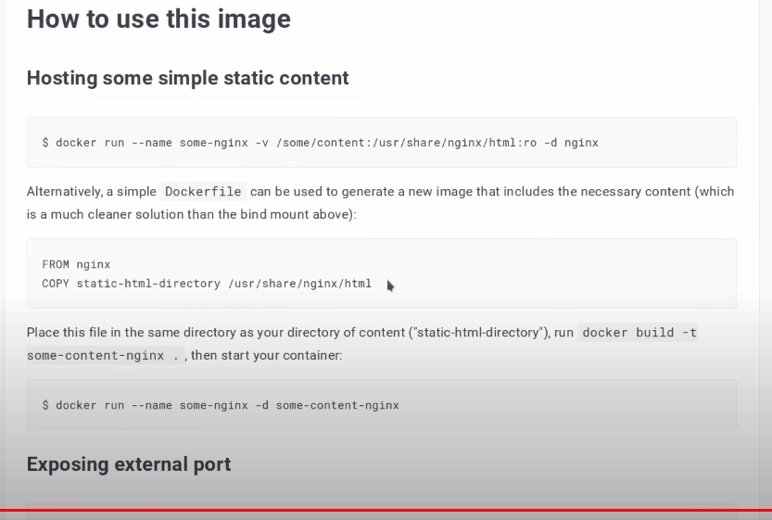

Next ---> go to github – go to repository ---> create a file named Dockerfile (put D as caps)

FROM nginx
COPY . /usr/share/nginx/html

--- commit changes ----> when we commit jenkins automatically runs the pipeline

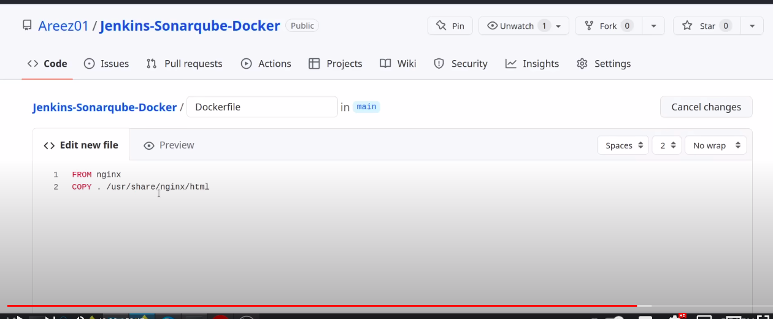

Next --- go to jenkins pipeline --- see here the build job is triggered ---> after success --->
go to configure ---> remove the remote shell ---> select execute shell --->

Now we are copying current content to the remote server (docker) --->
in execute shell ---> mkdir website --> scp -r ./* ubuntu@<publicip>:~/website/ ---> save

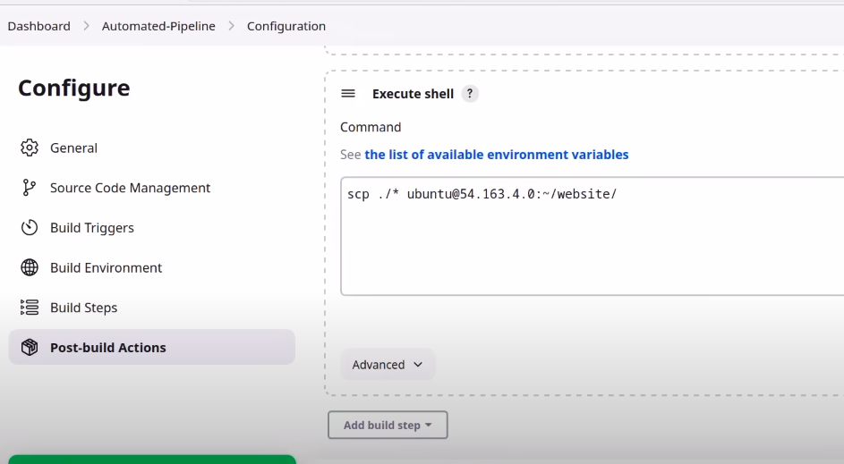

Note: we can failed on sonarube ---> go to sonarqube server --> lets find what is the error --> bcoz of dockerfile it find bugs on dockerfile ---> nothing to worry about ---> we should not put the Dockerfile in the Repository ----> we create a separate folder for that ---> fro now leave it

--Build now ---> we got the success msg ---> lets verify ---> go to docker server --> cd website --> ls --> here we see the content --->

Now we are going to Build the Image And run a container from it
--------------------------------------------------------------------------------

go to pipeine ---> go to job ---> configure ---> add buils step --> select remote shell --> save it

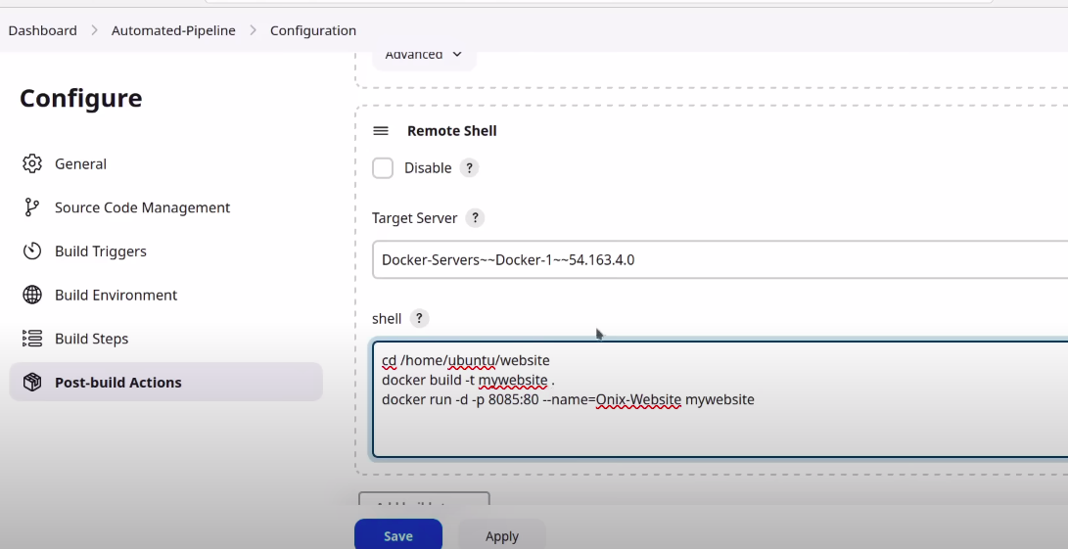

cd /home/ubuntu/website
docker build -t mywebsite . -------------------------------------- create image with name mywebsite
docker run -d -p 8085:80 --name=Onix-Website mywebsite

--- save it

-- go to jenkins ---> go to jobs --> Build now ----> After sucess --> lets verify

---> go to docker server ---> docker ps ---> here the container runs on port 8085 --> so we add this port in docker server instance ---> go to aws – go to docker --- security group ---add rule ---8085 from anywhere –save

--- go to the browser --> copy pubic ip of docker ---> <publicip>:8085

Now the website is runing --------------------------------

